Breathe-96 Quick Start Guide

This guide is designed to quickly allow you to get the Breathe-96 system up and running, customized to the conditions you need for your current run.

There is one preliminary step before launching the main program. This is setting the number of measurements for each step in the program, from equilibrium through the bumetanide step. Figure 1 illustrates how to get to this file and what the contents of this file looks like.
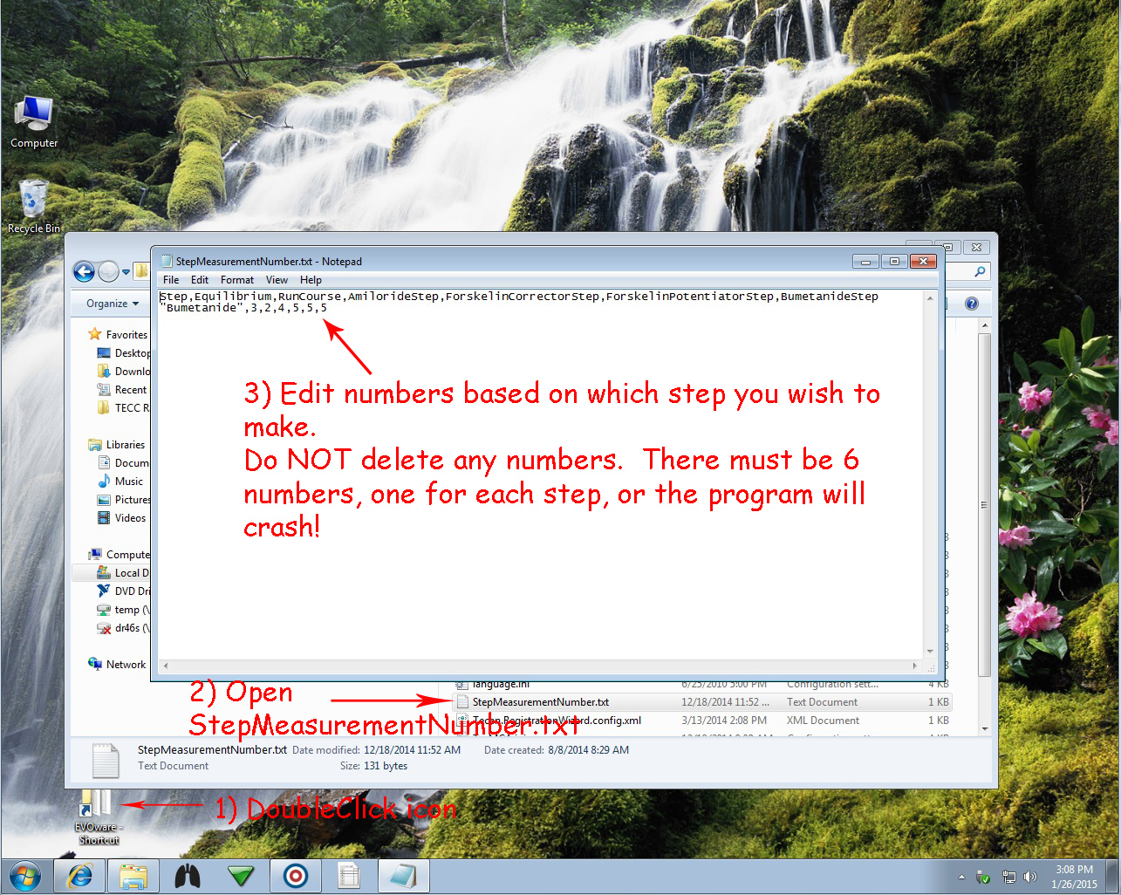
Figure 1

After making the changes to the StepMeasurementNumber.txt file, close it and launch the main marked in Figure 2.
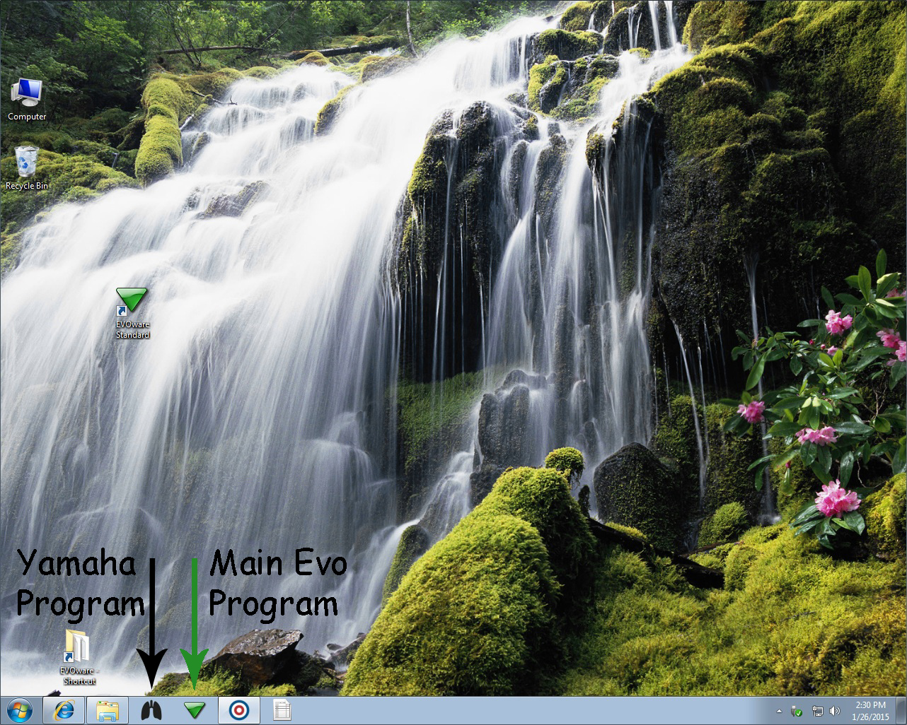
Figure 2

This will launch the main program that runs the protocol. A runtime controller window will open after EvoWare initializes. Click Run and this will begin the script (Figure 3).
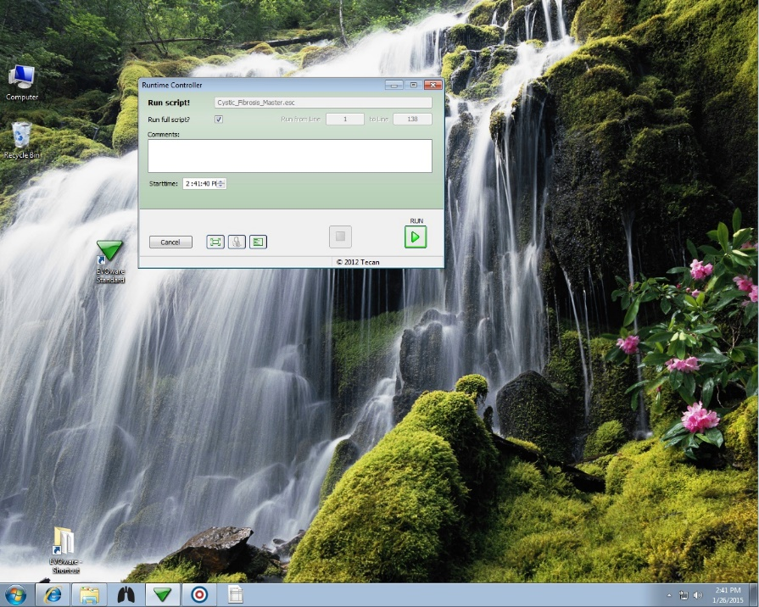
Figure 3
DON’T WORRY IF THE BLACK LUNGS PROGRAM ISN’T RUNNING! The script will launch it automatically as well as set up the TECC. After clicking run there will be a series of three questions that will determine which protocol to run. They are as follows:
- First question is always the number of plates. This is self-explanatory.
- 1 = common pot. plate 2 = separate pot. plates
This question is asking whether or not you are using a common potentiator across all the plates to be run. If that is true, select 1.
You will need to put the common potentiator plate in position 5
If you are using separate potentiator plates for each of the plates to be run, select 2
These plates will go in their respective positions (1-6)
- 1 = Forsk + pot. In one plate 2 = sep. plates
This question is asking whether or not the Forskolin and the potentiator are in the same plate. If they are in one combined plate, select 1:
If you selected 1 then there will be no separate Forskolin step or measurement! It will be combined with the potentiator step and will use the potentiator number of steps in the StepMeasurementNumber.txt file. Do not delete the ForskolinStepNumber variable though!
If they are in separate plates, select 2
After you finish answering the three questions the system will automatically begin. There shouldn’t be any user input required until after the program has finished. If you wish to monitor the measurements as they occur, there is a Spotfire program that has been written that will allow datalog monitoring of all 96 electrodes simultaneously.

